Aim: - Installation of Kali Linux, Virtual Box and Implementation of Basic Linux Commands.

Software Required: -

Cisco Packet Tracer

Outputs: -

Procedure: -

Step 1: Download Kali Linux ISO Image

On the official Kali Linux website downloads section, you can find Kali Linux *.iso* images. These images are uploaded every few months, providing the latest official releases.

Navigate to the Kali Linux Downloads page and find the packages available for download. Depending on the system you have, download the 64-Bit or 32-Bit version.

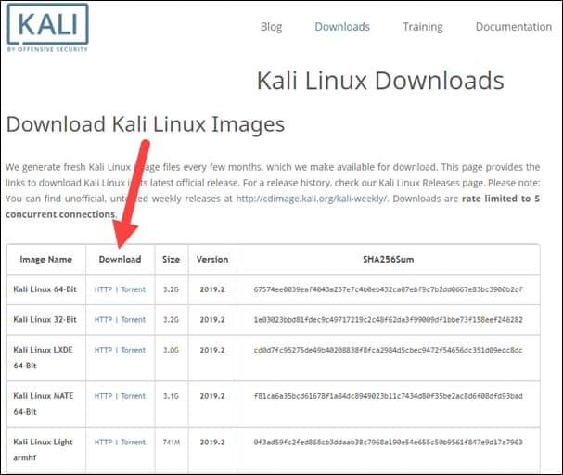

Step 2: Create Kali Linux VirtualBox Container

After downloading the *.iso* image, create a new virtual machine and import Kali as its OS.

1. Launch VirtualBox Manager and click the New icon.
2. Name and operating system. A pop-up window for creating a new VM appears. Specify a name and a destination folder.

The Type and Version change automatically, based on the name you provide. Make sure the information matches the package you downloaded and click Next.

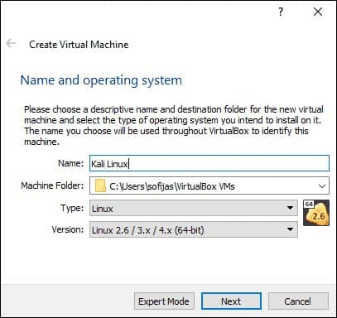

1. Memory size. Choose how much memory to allocate to the virtual machine and click Next. The default setting for Linux is 1024 MB. However, this varies depending on your individual needs.
2. Hard disk. The default option is to create a virtual hard disk for the new VM. Click Create to continue. Alternatively, you can use an existing virtual hard disk file or decide not to add one at all.

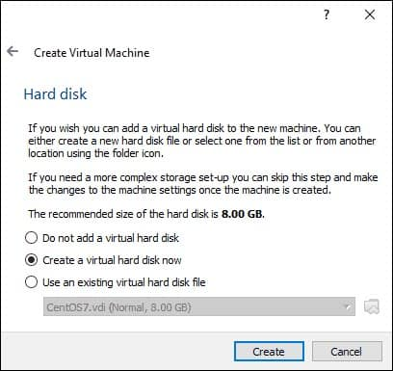

1. Hard disk file type. Stick to the default file type for the new virtual hard disk, VDI (VirtualBox Disk Image). Click Next to continue.
2. Storage on a physical hard disk. Decide between Dynamically allocated and Fixed size. The first choice allows the new hard disk to grow and fill up space dedicated to it. The second, fixed size, uses the maximum capacity from the start. Click Next.
3. File location and size. Specify the name and where you want to store the virtual hard disk. Choose the amount of file data the VM is allowed to store on the hard disk. We advise giving it at least 8 GB. Click Create to finish.

Now you created a new VM. The VM appears on the list in the VirtualBox Manager.

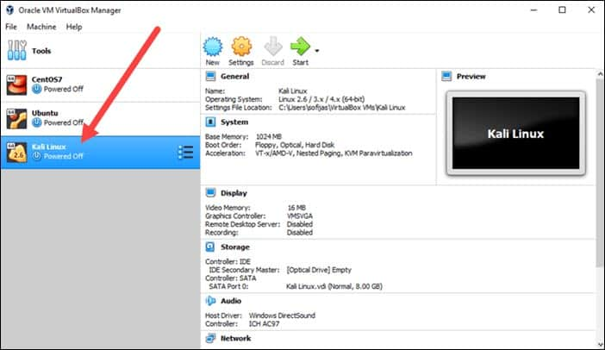

Step 3: Configure Virtual Machine Settings

The next step is adjusting the default virtual machine settings.

1. Select a virtual machine and click the Settings icon. Make sure you marked the correct VM and that the right-hand side is displaying details for Kali Linux.

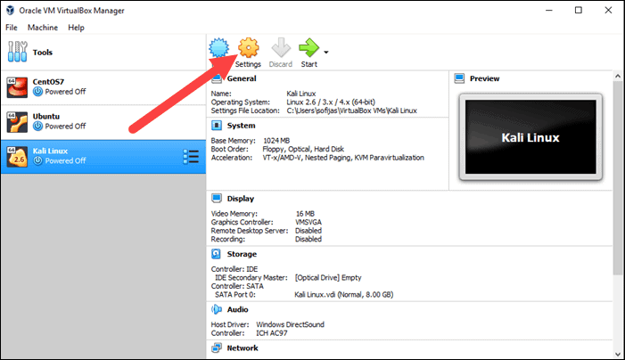

1. In the Kali Linux – Settings window, navigate to General > Advanced tab. Change the Shared Clipboard and Drag-n-Drop settings to Bidirectional. This feature allows you to copy and paste between the host and guest machine.

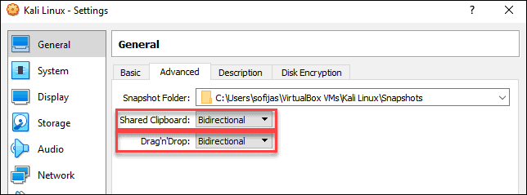

1. Go to System > Motherboard. Set the boot order to start from Optical, followed by Hard Disk. Uncheck Floppy as it is unnecessary.

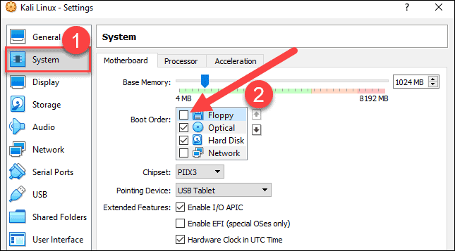

1. Next, move to the Processor tab in the same window. Increase the number of processors to two (2) to enhance performance.

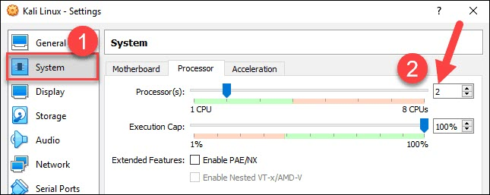

1. Finally, navigate to Storage settings. Add the downloaded Kali image to a storage device under Controller: IDE. Click the disk icon to search for the image. Once finished, close the Settings window.

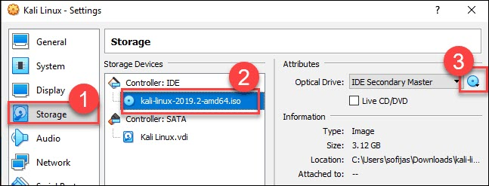

1. Click the Start icon to begin installing Kali.

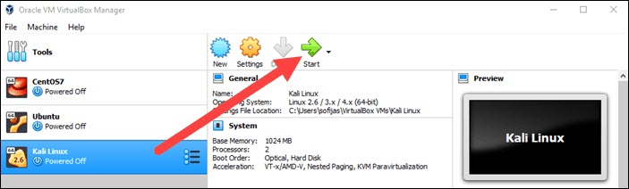

Step 4: Installing and Setting Up Kali Linux

After you booted the installation menu by clicking Start, a new VM VirtualBox window appears with the Kali welcome screen.

Select the Graphical install option and go through the following installation steps for setting up Kali Linux in VirtualBox.

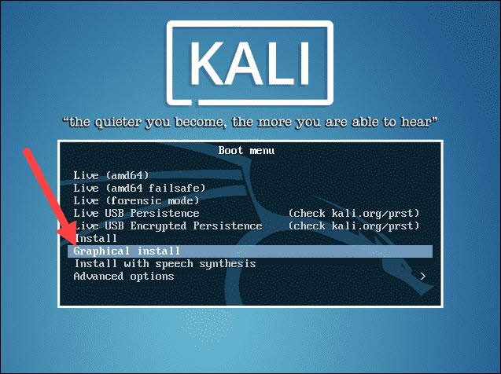

1. Select a language. Choose the default language for the system (which will also be the language used during the installation process).
2. Select your location. Find and select your country from the list (or choose “other”).
3. Configure the keyboard. Decide which keymap to use. In most cases, the best option is to select American English.
4. Configure the network. First, enter a hostname for the system and click Continue.
5. Next, create a domain name (the part of your internet address after your hostname). Domain names usually end in .com, .net, .edu, etc. Make sure you use the same domain name on all your machines.
6. Set up users and passwords. Create a [strong root password](https://phoenixnap.com/blog/strong-great-password-ideas) for the system administrator account.

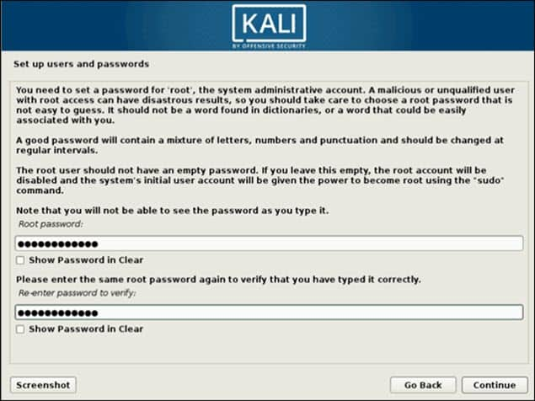

1. Configure the clock. Select your time zone from the available options.
2. Partition disks. Select how you would like to partition the hard disk. Unless you have a good reason to do it manually, go for the Guided –use entire disk option.

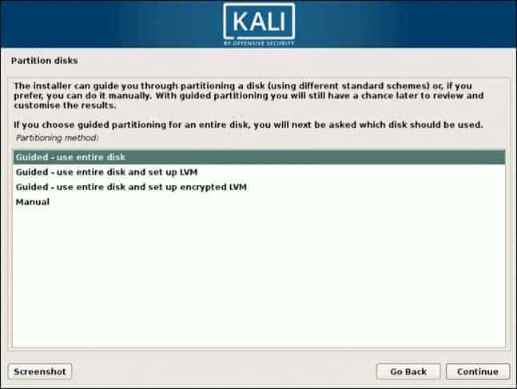

1. Then, select which disk you want to use for partitioning. As you created a single virtual hard disk in [Step 3: Adjust VM Settings](https://phoenixnap.com/kb/how-to-install-kali-linux-on-virtualbox#post-79896-_Step_3:_Adjust), you do not have to worry about data loss. Select the only available option – SCSI3 (0,0,0) (sda) – 68.7 GB ATA VBOK HARDDISK (the details after the dash vary depending on your virtualization software).
2. Next, select the scheme for partitioning. If you are a new user, go for All files in one partition.
3. The wizard gives you an overview of the configured partitions. Continue by navigating to Finish partitioning and write changes to disk. Click Continue and confirm with Yes.
4. The wizard starts installing Kali. While the installation bar loads, additional configuration settings appear.
5. Configure the package manager. Select whether you want to use a network mirror and click Continue. Enter the HTTP proxy information if you are using one. Otherwise, leave the field blank and click Continue again.

Install the GRUB boot loader on a hard disk. Select Yes and Continue. Then, select a boot loader device to ensure the newly installed system is bootable.

Once you receive the message Installation is complete, click Continue to reboot your VM.

With this, you have successfully installed Kali Linux on VirtualBox. After rebooting, the Kali login screen appears. Type in a username (root) and password you entered in the previous steps.

Finally, the interface of Kali Linux appears on your screen.

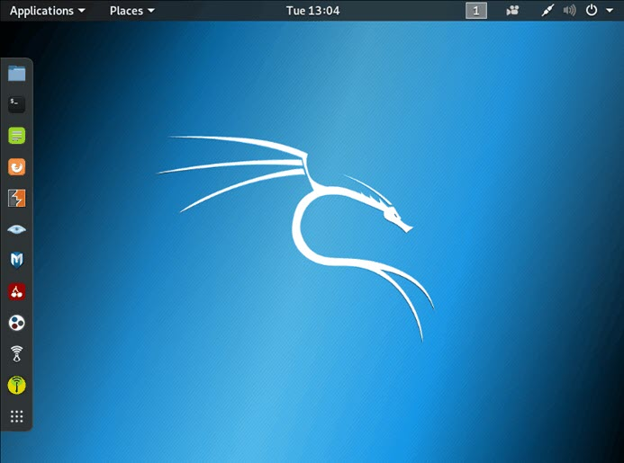

Simple basic Linux Commands: -

“pwd” – Present Working Directory

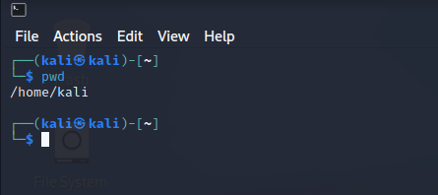

“whoami” – Gives Username

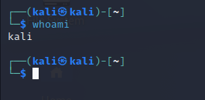

“ls” – Lists all Directories

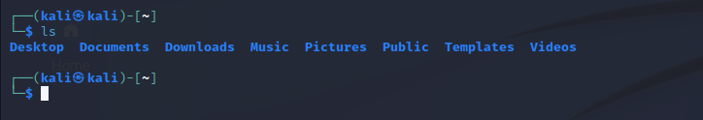

“cd” – Change Directory

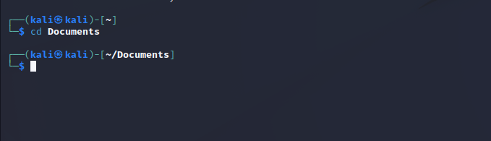

“mkdir” - Create a Directory

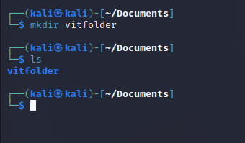

“rm -d” – Remove Directory

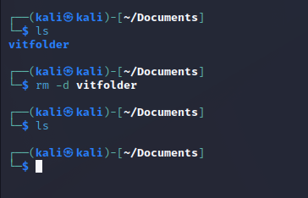

“nano high.txt”

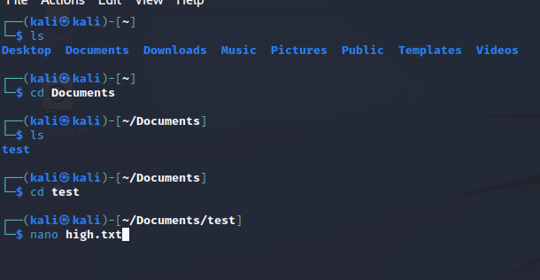

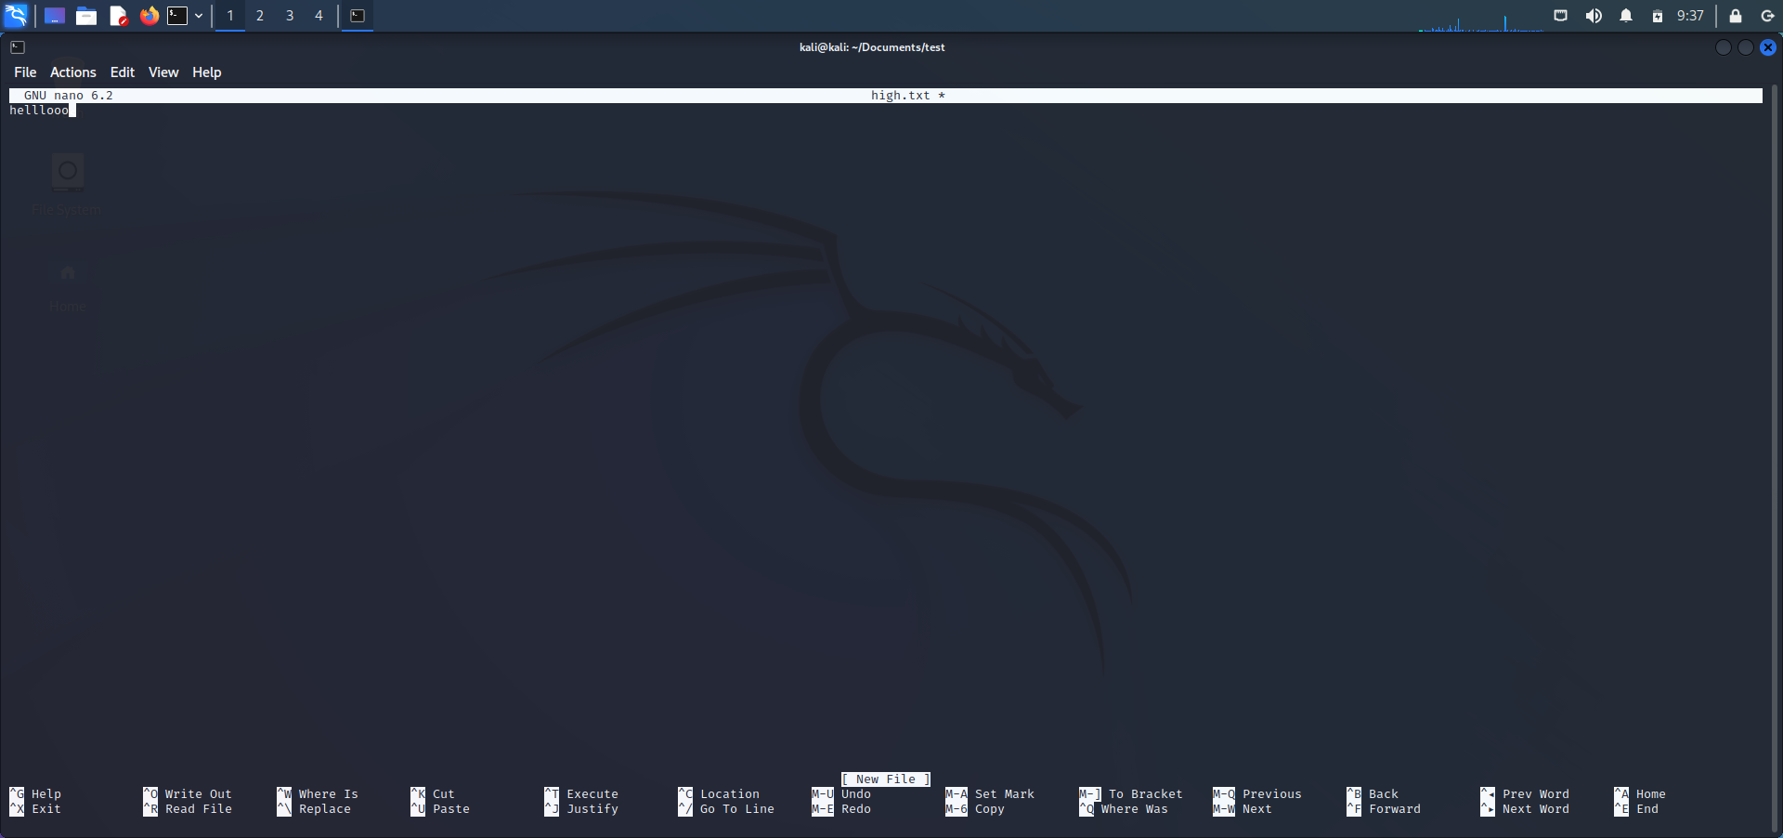

“cat high.txt”

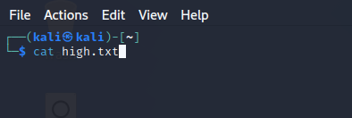

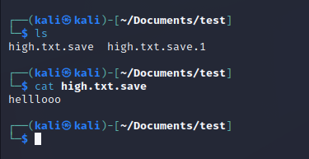

“echo”

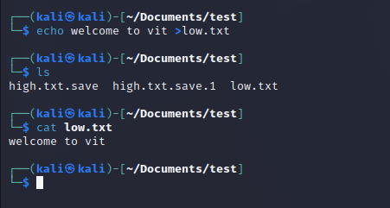

“ls -a, ls -l , ls -al , ls ..”

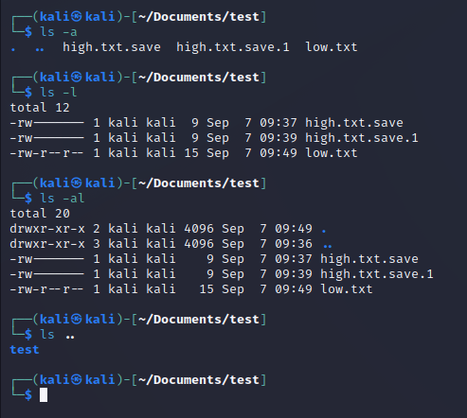

“cp high.txt mimi.txt”

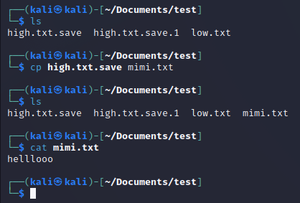

“cat high.txt mimi.txt”

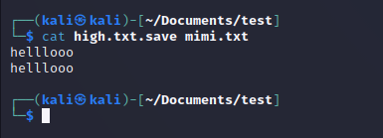

Result: -

Therefore, Kali Linux is installed on the Virtual Box and some basic operations are tested.